#NephJC Primer on
Twitter Journal Clubs
Version 1.5
Prepared by: Beje Thomas, MD, Joel Topf, MD, FACP
Cite as: Thomas B, Topf J, Hiremath S, Madariaga H, Lim M, Leon S, Shingada A, Colbert G, Sparks M. NephJC Primer on Twitter Journal Clubs. Version 1.4. www.NephJC.com/Primer
September 10, 2018

Overview
Social media is a novel tool for self-directed medical education. Social media is defined as websites, applications, or other platforms used to create and share content among multiple individuals separated by time and space. The specific platforms include blogs, wikis, videos, podcasts, and social network sites. Twitter is a social media site that is characterized by short posts of text, pictures, links, and videos. Users select a cohort of people to follow and Twitter constructs a (mostly) chronological list of these short posts to form a timeline. Twitter is popular among medical practitioners and is being used to disseminate medical research, discuss diagnostic and treatment challenges, and provide emotional support.
The idea of leveraging Twitter to run a medical journal club was first executed by Drs. Natalie Silvey and Fi Douglas who created TwitterJC. TwitterJC is now defunct but many of the practices developed by Silvey and Douglas remain a core part of the Twitter journal club experience. NephJC is a nephrology Twitter journal club. NephJC was founded in 2014 and has hosted over 100 chats. While there are many ways to organize a journal club this document outlines the what, why, and how NephJC is run. This is not meant as a prescriptive document, but rather a descriptive one that outlines how we have chosen to organize NephJC to meet the perceived needs of the nephrology community.
This is not meant as a prescriptive document, but rather a descriptive one that outlines how we have chosen to organize NephJC to meet the perceived needs of the nephrology community.
The user experience is key to increasing the adaptation of any media. Twitter is no different. As of now there is no written framework or model on how to develop and maintain a Twitter Journal Club. The purpose of the Twitter Journal Club Primer is to use our experience to construct a framework to aid in the development and growth of other Twitter journal clubs from the foundation up. Hopefully this document will provide hints and ideas that will be applicable to both novices and experts to improve their Twitter journal club experience.
A note on authorship: Each chapter has one or two authors listed, however all of the authors had opportunities during the writing to make comments, suggestions, and specific edits.
The Primer is a collaboration of the NephJC workgroup and NSMC Internship class of 2018.

Table of contents

Overview 1
Table of contents 2
Introduction 3
Chapter 1: Twitter 101 4
Chapter 2: Use of the Hashtag # 9
Chapter 3: Managing Chat 11
Chapter 4: Post-chat follow up and Archiving the Chat 16
Chapter 5: Etiquette 17
Chapter 6: Visual Abstracts 19
Chapter 7: The Website 22
Chapter 8: Newsletter 23
Chapter 9: Analytics 25
Appendix 1. NephJC Script 26
Appendix 2. List of Twitter journal clubs 28

Introduction
By Joel Topf @kidney_boy and Swapnil Hiremath @hswapnil

Twitter limits posts to 280 characters. This limit is a critical component of what makes the medium work for a journal club. Tweets must commit to a single succinct point. This limitation means that tweets are rapidly composed and quickly consumed. This makes a Twitter engagement feel like an interactive conversation instead of a one-way didactic session. The conversational nature is essential to what makes Twitter a good fit for a journal club.
NephJC started in April 2014. At the time the online nephrology community was just emerging from the primordial ooze of social media and venturing onto the dry land of Twitter. Both of the founders, Topf and Hiremath, were already active and visible members of the nephrology Twitter community, as primitive as it was. This was important for generating interest and gathering an audience for the earliest chats. In addition, the founders and early participants spent significant energy actively recruiting people to participate in the chats. Other endeavors flounder despite good content because the organizers did not have real or virtual connections to their respective online communities. A journal club cannot create a online community out of thin air.
Though a journal club cannot create a community de novo, it is an effective way to grow a community. If a journal club has a committed and dedicated core audience, (and it doesn’t take more than a dozen) it can become a beacon to draw other like-minded people to its cause and help strengthen a community. One of the most difficult jobs in selling social media to skeptics is describing the power and value of an online community. It is much easier to describe a journal club, primarily because it is a concept familiar to all medical practitioners. Once a person experiences a spirited and active Twitter Journal Club it is easier for participants to see the value of an online medical education community. We think one of the most important achievements of NephJC has been its role in building the nephrology Twitter community, #NephTwitter.

Chapter 1: Twitter 101
By Beje Thomas @bthomas215 and Hector Madariaga @HecmagsMD

Twitter has 336,000,000 active users. Twitter is also home to some of the most vital and active medical discussions. Here we hope to simplify Twitter for novices.

What should I consider before signing up for Twitter?
What devices can Twitter be used on? Computers, tablets, and smart phones using either Android or iOS
Twitter Username: This is the unique name that Twitter uses to identify you. Many people use a version of their name. Nephrology puns are appreciated. The Twitter username can be changed in the future, but some features are broken when that is done. The Twitter username always starts with an @. It is limited to 15 characters and cannot contain spaces. A Twitter handle is a synonym for a username.
Twitter Name: This is another way to identify yourself on Twitter. These names do not need to be unique. We believe that doctors should use their own name on Twitter and discourage anonymous accounts. The Twitter name can be changed and does not lead to problems with your account or prior tweets/data.
Avatar picture: A nice picture or selfie is usually used here. This can be changed as often as a user likes. This is an important part of completing your Twitter profile. People that don’t include a picture get less engagement and seem less trustworthy.
Background picture: On your Twitter profile page there is space for a larger picture. This is less important but can add to your presence.
Twitter bio: This is limited to 160 characters. It is often all that people see when they decide to follow you or not. Don’t leave it blank. Make those 160 characters count. You can change it at anytime.
Link: This is a way to link back to a website containing more information about yourself. Some options to use would be a faculty page from an institutional website, Doximity profile, Google Scholar, about.me or LinkedIn profile.

How do you start a Twitter account?
- Go to twitter.com and sign up by answering all of the questions.
- Alternatively, use a smart phone and start by downloading the Twitter app.
- Follow the prompts and enter the appropriate information.
- There are three options to customize your account include:
  - Let others find you by email or phone number. We suggest you do this.
  - Receive messages from Twitter about your activity and recommendations. We suggest you do this. You can turn this off later if it becomes annoying.
  - Receive personalized ads. We have no opinion on this.

Now you are live on Twitter. What are the next steps?
- Follow people and organizations that share the same interests as you. You can unfollow them at a later date.
- It is okay to just listen for awhile, but participating will increase the value of the service.
- To make Twitter useful it is essential to build a cohort of people to follow, a personal learning network. Follow accounts that engage with tweets you find interesting. Go to a relevant Twitter chat and follow the participants who make the most interesting comments. Follow the governing body of your specialty. Find your mentors and see who they follow and interact with.

Getting familiar with some of the conventions on Twitter
@ Symbol @ indicates an account on Twitter. @ always precedes a user’s name (i.e. @NephJC) and can be used to communicate directly with a user. If you are asked a question or want to direct a question to someone use @ and the recipient will be notified. This works even if the recipient does not follow you back. Adding someones handle to a tweet will make them notice the tweet and can increase engagement. Adding a long list of handles to a tweet makes it look like spam.
When using @ to direct a conversation with one or more people, keep in mind that this is still a public conversation and can be read by anyone. If you want to talk privately, use a direct message.
Direct Message (DM) is the only thing on Twitter that is not public. What you tweet, favorite, and retweet is all available to everyone. As is who you follow and who follows you. Direct messages are private and can only be read by the sender and the recipient. Even if you add a third person to the DM chain, the messages shared before that person was added are hidden from the newcomer. In order to compose a DM click on the envelope icon. Generally, one can only direct message a follower, though some accounts (including @NephJC) keep “open” DM and allow anyone to privately message them.
Direct Message (DM) is the only thing on Twitter that is not public. What you tweet, favorite, and retweet is all available to everyone. As is who you follow and who follows you.
DM is the preferred modality when you prefer to keep communication with someone private on Twitter. In order to make a DM click on the messages icon. You can generally only direct message someone who is following you, though some accounts allow anyone to DM them.
Groups of people (maximum size is 50) can communication via direct messages as well. This is a convenient way for teams to communicate.
The Hashtag # A pound sign followed by a word is a way to tag tweets with a subject. Clicking a hashtag will link to all the tweets with that contain that same hashtag. This will include tweets by people one does not follow. Hashtags are a great way to find new people to follow.
See Chapter 2 on Hashtags by Michelle Lim

How to interact on Twitter
When you see a tweet that you appreciate there are four ways you can show this appreciation (in order of increasing engagement):
- Favorite it by pressing the “heart” icon. The author will receive a notification that someone liked the tweet.
- Retweet it. Pressing the retweet button will republish the tweet so their followers will see the tweet. The original author of the tweet will receive notification of the retweet. Tweeters love retweets. You can retweet your own tweets.
- Reply to the tweet. Replying to the tweet with one's own comments is a great way to show appreciation of the comment and a way to take the tweet further, develop the ideas, or extend them in interesting ways. The original author is notified of the reply. Important notice: only people who follow both parties (the replies and the original commenter) will see the reply. To make sure all of one can see the reply, use retweet with comment.
One can reply to oneself. This is the best way to make a point larger than 280 characters and allows the creation of a multi-tweet thread or tweetorial.
- Retweet with comment. This is just like a reply except all of your followers will see the reply, not just people that follow you and the original poster.

Accessing Twitter
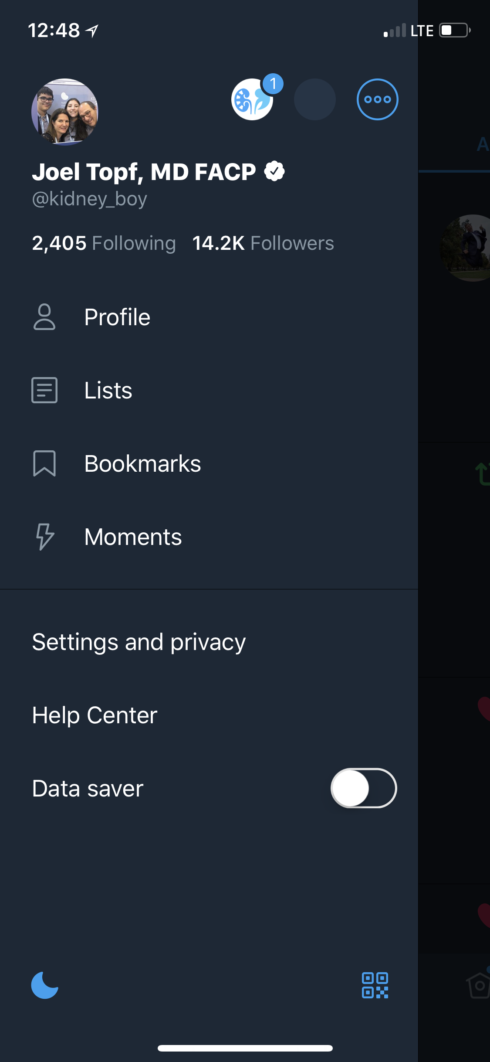
There are a few different ways to access Twitter. On the desktop, the best option is the website Twitter.com. On tablets or phones use the official Twitter app. For more advanced users there is TweetDeck.

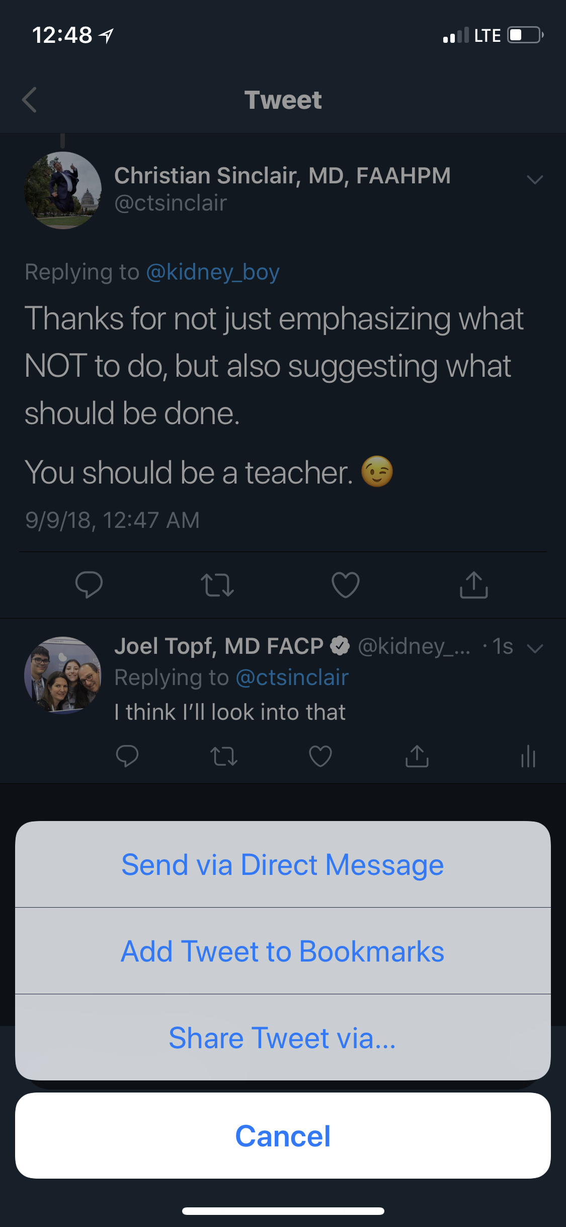
Bookmarking Tweets
The bookmark feature allows you to save content to be read later. This can help when there isn’t time right then to contemplate a tweet. A tweet can also be saved by using the favorite button, however favorites are public and bookmarking is private.
3
1
How do you bookmark a tweet? To the right of the favorite button is the share button that appears like an underlined arrow (1). Click this to reveal options to share the message, select Add Tweet to Bookmarks (2). To view bookmarked tweets, tap on your Profile icon (the picture for your account on the top left) and this will reveal the menu including the Bookmarks list (3) as well as Twitter Lists and Moments. Bookmarking is not available on Twitter.com, only in the app.
2

Twitter Moments
Twitter Moments are great ways to summarize a group of tweets. Basically, it is a collection of comments and interesting points made during the chat. The Twitter Moment can be created from the Moment tab on your profile page or from a single tweet.
For further information on creating Twitter Moments see: https://help.twitter.com/en/using-twitter/how-to-create-a-twitter-moment
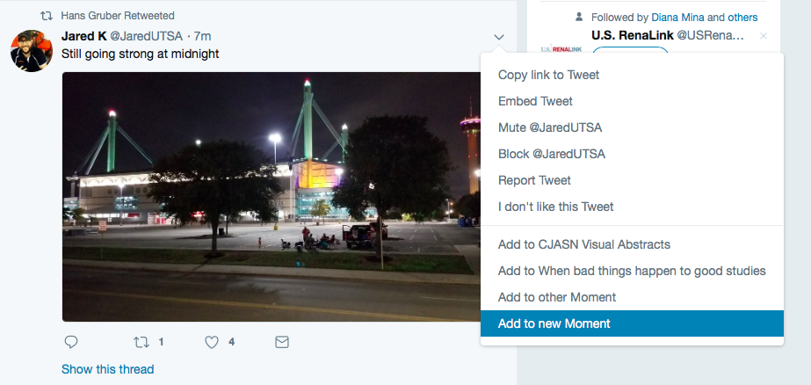
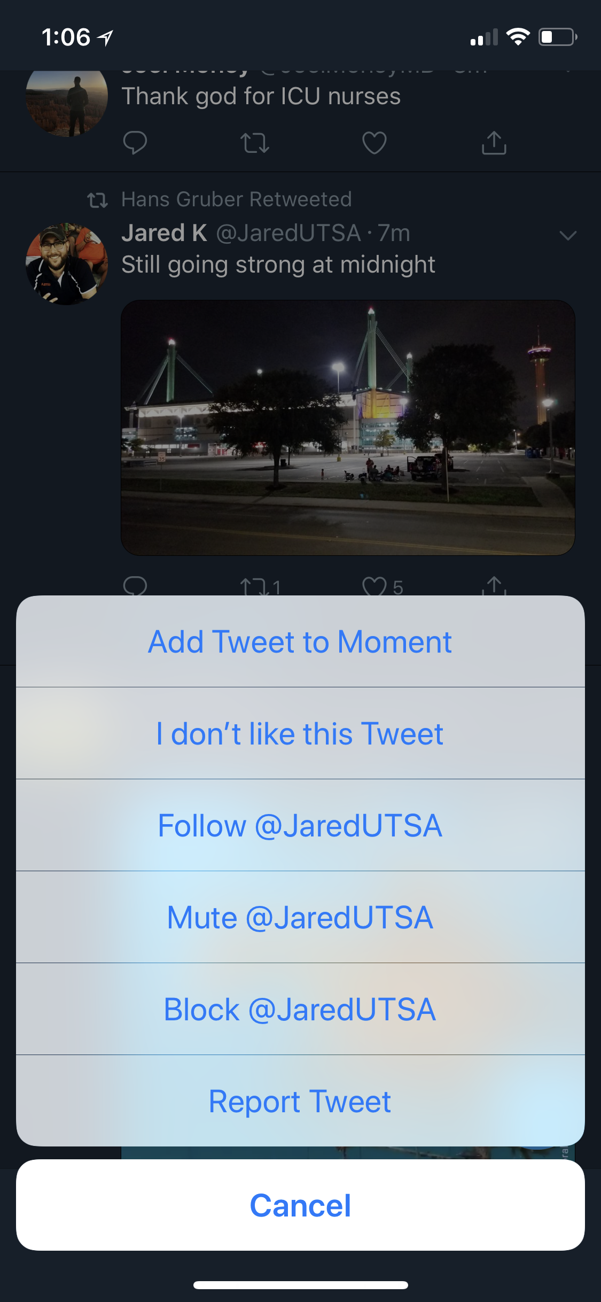
1
2
2
1

Chapter 2: Use of the Hashtag #
By Michelle Lim @whatsthegfr

In 2007, @chrismessina was the first person to tweet a hashtag. Hashtags are short, unique words or phrases that label tweets. They are prefixed by the pound sign (#), and cannot include spaces or punctuation. Hashtags allow tweets to be indexed and searchable. They can be used to filter Twitter. The Twitter timeline only shows tweets from people one follows regardless of what they are talking about. When one follows (click on) a hashtag they see people’s tweets containing that hashtag regardless of whether they follow the authors or not. For example, clicking on #NephJC reveals a chronological list of tweets tagged with #NephJC, but will show no tweets about anything else.
Hashtags work as virtual meeting rooms at a conference. The aim is to ensure that the meeting rooms are general enough so it gains enough participants to provide a robust conversation while being specific enough that the discussions are focused on subjects of interest. Unlike actual conferences, these discussions remain active, as long as the particular hashtag continues to be used.
A Twitter journal club needs a hashtag and only one hashtag that doesn’t change chat to chat. The hashtag is a primary part of the journal club’s identity.
It is important that a journal club select a unique hashtag that will not be contaminated by others using it outside of the journal club discussion. For example, #MedEd is a Thursday night discussion on medical education. The hashtag is also a general hashtag used to tag medical education content. Thus, every Thursday the flow of the #MedEd chat is disrupted by people not participating in the chat using the same hashtag to label medical education content or thoughts.
All things in moderation. A good rule of thumb is to use only one or two hashtags to minimize reader fatigue and save precious characters. Tweets with more than two hashtags show a 17% drop in engagement. Consider using a hashtag unique to your journal club (e.g. #NephJC) and another related to the topic being discussed (e.g. #cardiorenal). This will index your tweets among other related tweets. Some journal clubs add a hashtag to track where the conversation is, so there will be hashtags for #introduction, #topic1 (often abbreviated #T1), #topic2 (#T2), #wrap-up, etc. When using a hashtag to participate in a conversation make sure that you are using the official hashtag to minimize confusion (It’s #KidneyWk not #Kidney_Week2018SanDiego).
Here are some useful kidney related #hashtags:
#NephJC: The hashtag for the Nephrology Twitter Journal Club.
#NephPearls: The hashtag for pearls of kidney wisdom.
#AskRenal: Have a question while studying renal physiology or nephrology? This is the hashtag for you.
#WomenInNephrology: For promoting the contribution women make to nephrology and for pointing out misogyny.
#NSMC: Hashtag for the Nephrology Social Media Collective Internship that runs from December to December of each year.
#FOAMed: Stands for free open access medical education. Tags tweets with medical education content.
#TipsForNephFellows: The hashtag for useful tips to be a superior nephrology fellow.
#NephForward: Tags tweets showing the successes in nephrology.
Additional reading on the do’s and don’ts of hashtags: https://blog.hootsuite.com/how-to-use-hashtags/

Chapter 3: Managing Chat
By Hector Madariaga @HecmagsMD
In order to participate in a Twitter Journal club, one needs to reorient the Twitter client so that instead of following a timeline it follows the Journal Club’s hashtag. This can be done by clicking the hashtag but a better way to do this is with TweetDeck.

What is TweetDeck and how do I use it?
TweetDeck application is accessed through a browser and provides a number of useful ways to view Twitter. TweetDeck uses a multi-column view to allow the user to track multiple Twitter streams at once so it is great for people with multiple Twitter accounts. It is also the best way to participate with a Twitter Journal Club.
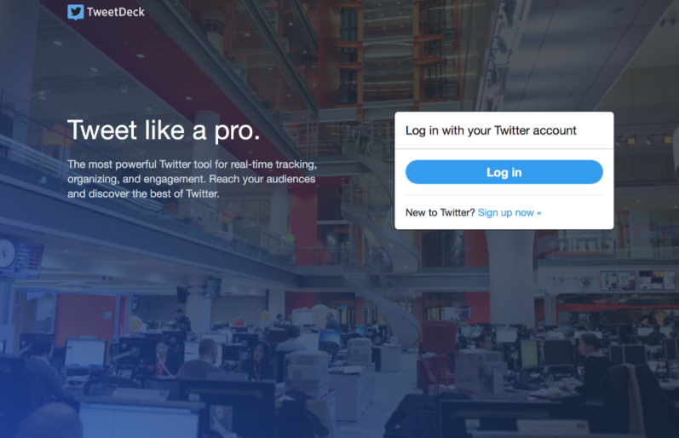
To logon go to http://tweetdeck.twitter.com, or download and open the desktop app.

Log in with a Twitter account.
Advanced: TweetDeck supports multiple Twitter accounts. Click Accounts in the navigation bar, enter the @username of the account to add under “Link another account you own.” Then in the new window enter the password and click authorize and it will be added.
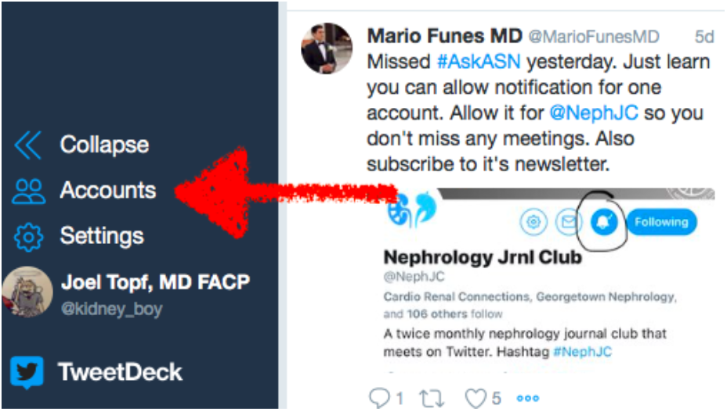
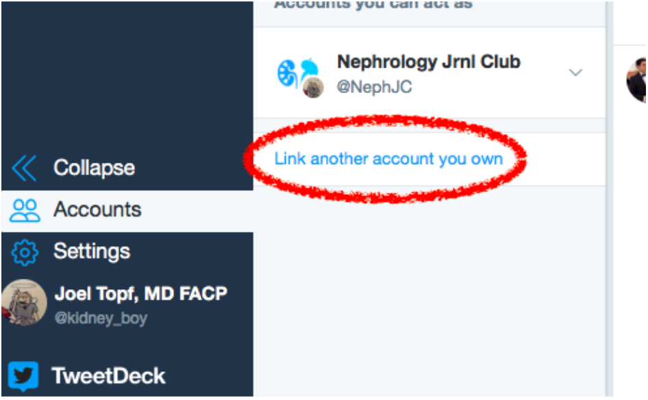

Once logged in, TweetDeck has multiple columns that can be customized.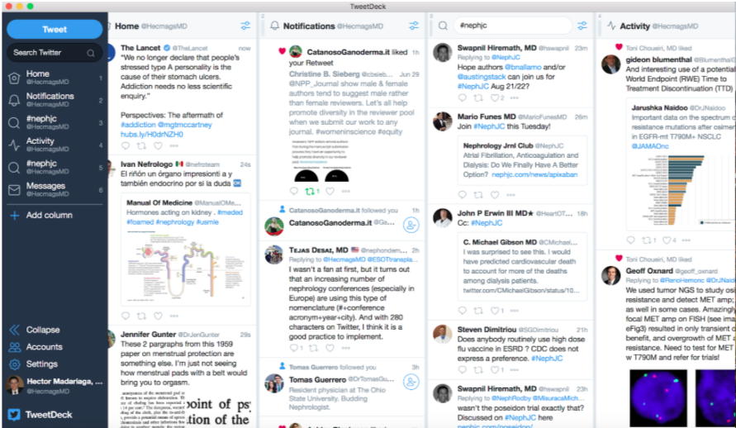
The Home column is the standard Twitter timeline. Notifications should also be familiar. A search column allows one to see tweets meeting the entered search criteria. A column can be set to track the tweets from a Twitter list.
There is also a Schedule Tweet button to compose multiple tweets to be sent out at a specific time.
A key feature of TweetDeck is making a collection of tweets. How to do this?
- Add a column by clicking the + icon on the left side of the navigation bar.
- Select Collections from the menu options.
- Drag curated tweets to the Moment column.
- To share the collection click on “Settings” icon at the top of the collection and then select the “Share” menu and select to view it on Twitter or tweet with a link to it.
TweetDeck is an ideal tool for Twitter journal clubs. Create a Search column and put the journal club’s hashtag in the search box. The column is now tapped into the journal club feed. In a high volume chat there may be a delay in showing new posts. Be patient. TweetDeck shows polls, images and allows the user to write and read 280 characters.
More information about TweetDeck can be found at: https://help.twitter.com/en/using-twitter/how-to-use-tweetdeck

Participating in the Chat
When participating in a Twitter journal club, it is important to add the hashtag to every tweet and reply so that other people participating in the chat will see your contribution.
For numerous reasons it is best to use replies (with the appropriate hashtag) as much as possible.
Look for the host to ask questions and reply with your thoughts.
It is ok to try to read every tweet and fall 10 or 30 tweets behind the top of the discussion. Participants should continue to read the stream in chronological order. It is okay to reply to old questions or comments even if the leaders have moved on. When replying to a previous tweet, the reply will be put at the top of the stream, but since it refers to an older part of the conversation it allows people to understand the context of the reply.

Hosting
If you are hosting the chat it is essential to pre-compose the core tweets prior to the discussion. By pre-writing a script for the journal club you can confirm that you have all of the angles that you want to cover in the discussion. It also relieves some of the burden of hosting the chat so the host has more time and attention to engage the audience.

The structure of NephJC
Here is a brief outline of the chat. In Appendix 1 there is a sample script.
Introductions and Topic Zero:
- Remind everyone to use the hashtag #NephJC.
- Ask people to introduce themselves and reveal any conflicts of interest (COI).
- An important role of the host is to say hello to people as they check in. The host needs to make everyone feel welcome.
- While people are showing up and assembling, have a general question for people to chat about before embarking into the meat of the article. Usually this will be about how providers took care of patients prior to this article or how often they see patients similar to the cohort studied. We call this Topic Zero.
Topic One: Start with the methods. The host should have a few tweets describing the methods, but the host’s role is not to be didactic here. Do not give a lecture in a 100 tweets. Try to present some aspect of the methods and then follow it with a question for the audience. The goal as the host is to guide the audience through the article but leave it to the participants to make the brilliant observations. The key to a successful journal club is audience engagement and interaction. Occasionally, if the topic being discussed is controversial, background information can be discussed to understand the context of the study.
Topic Two: Talk about the results of the study being discussed. You can include figures, tables, or text with your tweets. Again the idea is to present a result and then ask a question to engage the audience.
Topic Three: Start a discussion of the consequences and significance of the findings.
Closing Statements: The moderator asks the participants for their final thoughts about the discussed article for instance, if the results impacts their practice or whether they will change their respective diagnostic approaches or management. Also remind those participating in the chat of the importance of following others in the chat to build their personal learning network.
The host can expect to tweet 60 to 100 times during the one hour chat.
If you are the host it is important to see and react to tweets at the very top of the chat.
The host can try to guide the discussion, but the chats may take on a life of their own and branch off into unexpected directions. That is okay. The host should do her best to guide it, but shouldn’t worry if an active discussion takes an unexpected diversion.
It is important to note that Twitter can lock you out of the account during an active chat session. If this happens you must exit and log back in using the same Twitter account. However, when logging back in you will have to change the password. The link to change the password will be sent once requested to the original account owner's phone or e-mail account. This is especially complicated when the hosting duties rotate from host to host every week. It is important for the person with the registered phone and e-mail account to be available when this occurs to facilitate the host getting back on line.

Chapter 4: Post-chat follow up and Archiving the Chat
By Hector Madariaga @HecmagsMD
The Nephrology Twitter Journal club is largely designed to be delivered as a live performance. When people stumble across the discussion days or weeks later it is difficult to piece together what was said and what was meant during the chat. In order to take care of this we curate the chat so it can be better accessed at a later date and continue to provide educational value.
Content curation should include the most valuable tweets. Curating the chat soon after it is complete is the best practice. As tweets age it can be difficult to access some of them. We use Twitter Moments to curate #NephJC tweets. We have a dedicated group of editors that create the curated moments. They are aware of their responsibility before the chat happens.
The moments created for #NephJC can be viewed here: https://twitter.com/NephJC/moments

Chapter 5: Etiquette
By Scherly Leon @SLeonMD
Etiquette is a set of guidelines for politeness and good manners, the kindnesses with which we should always treat each other. Twitter journal clubs have there own customs and etiquette in order to be productive, educational and inviting environments.

Twitter Journal Club Etiquette 101
NephJC does not have a published code of conduct but these are some principles that we use to guide our own behavior and that we think result in a productive and supportive environment for scientific discourse.
Be honest/transparent. Disclose conflicts of interest (COI) early on in the discussion. Sometimes a user will use an alternative handle. This happens when someone hosts a Twitter chat or journal club and uses the handle of the organization (@NephJC). It is best for the author to announce their identity. Do not hide behind the name of an organization.
Be professional. While social networks may “feel” like informal settings, they should be regarded with the same respect as any public place of business. If you would not say something in a work setting, do not say it online.
Be positive and genuine. Maintain a positive tone and attitude. There is no need for negativity and condescending posts. If you find you are becoming emotional as a result of an interaction, pause and reflect before replying. Not every interaction requires a response.
Be literate. Avoid posting with poor spelling, inaccurate punctuation, or substandard grammar. Carefully choose words that sharply and accurately convey your intensions. Proofread all tweets before sending. Be your best.
Be respectful. Not all of us agree all the time, but disagreement is no excuse for poor behavior and manners. We may experience frustration now and then, but we should not allow that frustration to turn into personal attacks. It is important to remember that a community where people feel uncomfortable or threatened is not a productive one. You do not want to be, or even perceived to be, a bully or closed minded.
Be polite and clear. Online conversations, like texting, have challenges. Often conversational nuances and subtle shifts in tone are lost in the translation to text. This leads to misinterpretation of intent. Irony and sarcasm are easily missed. Be careful when using these techniques. Often tweets can be taken out of context to the embarrassment of the writer. This is why it is important to consider how posts will be read and perceived before sending. We all have opinions, some people are more opinionated than others, however realize that social media opens you up to instant scrutiny/criticism.
Be mindful of the larger audience. During an active tweet chat, the apparent audience is people that are actively tweeting. However there is a larger audience of people who are listening but not otherwise engaging. This may include patients, family members, or people with less sophisticated medical knowledge. Be mindful of this larger group and avoid statements that may confuse or insult them. What is an arbitrary outcome to you maybe the death of a child to them. Remain professional. Avoid providing medical advice. Do not answer medical questions or engage in clinical conversations with patients. Create or adapt a blanket statement like, “Please address this with your health professional.” or “I’m a doctor on Twitter but I’m not your doctor on Twitter.”
Be friendly and fun. We are doing something exciting and different. Many are watching and looking to be involved. We are leaders and our behavior should encourage others to want to get involved!
Apologize. Occasionally you may tweet something we suggest you should not, and regret it. It is human to make mistakes. Just delete, apologize, or clarify as appropriate.

Chapter 6: Visual Abstracts
By Aakash Shingada @aakashshingada

Why do you need to make them?
Visuals express ideas quickly - in a snapshot. A visual abstract is a single, concise, pictorial and visual summary of the primary findings of the article. It is the visualization of the written information thereby adding a new path toward understanding –or “seeing” the meaning of the text.
The life blood of any journal club is a cohort of engaged and vocal participants. Visual abstracts may provide concise, relevant information within a few seconds and may help increase participation. A visual abstract is not a substitute for reading the article and deliberately does not contain all the details of an article.

How to make them?
Begin your journey with visual abstracts by going through Andrew Ibrahim’s primer on #VisualAbstracts. This is the most important step. We are repeating it intentionally. Start by reading Andrew Ibrahim’s primer on #VisualAbstracts.
Watch this two-minute video on creating a visual abstract.
The visual abstract team at CJASN has also written about their experience and best practices for creating a visual abstract. Read it here.

Some Do’s and Don’ts:
Software: The visual abstract creators at NephJC use a variety of tools. Microsoft Powerpoint, due to familiarity and ease of use, is the most common tool used for the creation of visual abstracts. One of the unique advantages of PowerPoint is that it is common platform so visual abstracts can be shared and edited by multiple users.
Other software that can be used include:
- Apple Keynote
- Adobe Illustrator and Photoshop
- CorelDraw
Keep it visual: The trickiest step in creating a visual abstract is to find the right balance of information to add. Remember the goal of the VA is not to provide all of the depth or subtlety of an entire article (or even the abstract). The creator can easily add too much information and clutter the visual abstract. This defeats the purpose of making the article visual.

When making a visual abstract a policy of less is more will serve the designer well. Use larger icons, numbers and as little text as possible to convey the information.
Color schemes: It is very important to use the right color scheme for your visual abstract. Though this seems like a straightforward task, it can often be a reason for despair for the person creating it. This online color scheme generator can be helpful.
Use the crowd: After completing an initial draft of the visual abstract, show it to people and solicit comments. Do not be defensive. Listen to the criticisms carefully. If people are confused, go back and rework it. Putting a visual abstract down for a day or two and then coming back also provides novel insight and inspiration.
Copyright: Do not steal.
- Icons: Use free icons from iconfinder.com or sign up for a paid Noun Project account. Nothing beats original content, so where possible create novel icons. Be creative. Combine multiple icons to come up with new ideas:
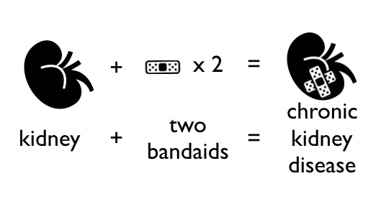
- Visual abstracts: Now that visual abstracts are more popular, many articles have their own visual abstracts. Be careful not to copy existing ideas. Consider contacting the designers of previous visual abstracts to get permission to borrow icons or concepts.
- Journal logos: Avoid using the journal logos on the visual abstracts unless you officially represent them. Using journal logos can make it appear that the visual abstract is an official publication of the journal.

How to optimize the impact of your visual abstract
Quality of image: Use a high resolution image to ensure legibility. This will not only enable readers to visualize the VA on their devices, but it will allow the visual abstract to be used in presentation slides. Visual abstracts from NephJC have repeatedly been show in local, regional, and international presentations. When designing the visual abstract remember that most people will be viewing it on a phone. The standard phone display is 16x9, try to match the visual abstract to that aspect ratio.
Timing of release: While the summary should be released well in advance to allow the participants to read, the visual abstract may be released a couple of days before the chat, to refresh the salient points of the paper. This also acts as a reminder for the chat and builds momentum leading to the chat.
Maximizing outreach: There are several means that can be employed to maximize the dissemination of the visual abstract. Make sure to hashtag the tweet #VisualAbstract. There are a number of people who scour this hashtag for for fresh examples and will retweet good work. If the author is on Twitter, tag them and invite them to publicize it. Tag the publishing journal, some of which may have a social media team, who may share the visual abstract.
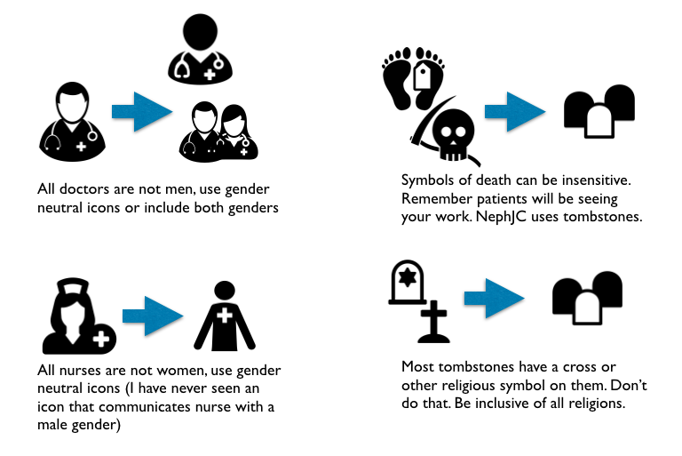
Maintain professionalism: Tweets shared on social media can potentially spread to millions. Take time to re-evaluate your work. Spelling errors, poorly aligned objects, incorrect information makes your work appear sloppy and should be strictly avoided. Avoid insensitive and insulting icons.

Chapter 7: The Website
By Joel Topf @kidney_boy and Swapnil Hiremath @hswapnil
Despite the obvious emphasis on Twitter, a Twitter journal club needs a home on the web.The website fulfills multiple functions:
Promotional. The website announces upcoming chats.
Educational. The website hosts a summary of the upcoming article in order to help people who may not have access to the article or insufficient time to be able to quickly glean the important aspects of the trial. These summaries are promotional for the chat but after the chat they continue to glean traffic and become an in-depth and open access summary of the study. In addition to the summary, NephJC posts additional editorials highlighting various aspects of the study. NephJC regularly hosts editorials about statistics and trial design (http://www.nephjc.com/news/?tag=Stats) as well as articles by patients about their experience with disease and therapies so doctors can see these important and under-shared perspectives (http://www.nephjc.com/news/?tag=Patient+Voice).
Archival. The website keeps a record and archive of all the previous chats.
The website is the hub for all the activities of NephJC.
Twitter by its nature is very ephemeral. It is difficult, though not impossible, to search Twitter. Once a chat has passed, it is difficult to re-live it in order to glean the best thoughts and angles on it. The website is the starting point for searching previous chats and the specific lessons from these chats. The website is an essential part of a living archive.
We use SquareSpace to host and build the website. It provides good flexibility and is easy to use.

Chapter 8: Newsletter
By Gates Colbert @DoctorGates
It’s hard to believe, but a great number of people do not obsessively check their Twitter feed. People use different sources to gather information and news about upcoming events. The newsletter for NephJC is an additional channel NephJC uses to communicate upcoming chats and other events. It has been paramount contributor to the success of NephJC. NephJC uses Mail Chimp to construct and send the weekly newsletter.
Individuals sign up for the chat at the NephJC website: http://www.nephjc.com/mailing-list/
The weekly email is sent to 1,300 people (September 2018) who have requested to regularly receive it. The e-mail subscriber list is far larger than the 100-200 people that typically participate in the Twitter chat. In a survey of NephJC users we discovered that a large number of people access the NephJC information (summaries wrap-ups, and editorials) without ever participating in a NephJC chat. Because of this we have explored additional channels for distribution. E-mail is one of our most successful.
The newsletter has a clean and predictable format that is sent out at the beginning of each week. The newsletter team tries to send it at the same time every week. The newsletter has a standard format:
Next Chat announces the next chat, either #NephJC or #AskASN. It includes the date, time, and article information. It links to the primary article as well as the summary and visual abstract if they are available.
Last Chat reviews the last chat with links to the article, NephJC summary, archival Twitter Moments, and the visual abstract.
Conferences announces upcoming nephrology conferences.
Now Hear This links to recent events, discussions, or news of importance to the Nephrology community. Our reader base likely has an interest in recent social media and #NephTwitter happenings and the most relevant events are highlighted.
In sum, the newsletter is a marketing and educating tool for NephJC and #NephTwitter.

Newsletter published 9/3/2018

Chapter 9: Analytics
By Matt Sparks @Nephro_Sparks
Analytics are an important component to a successful Twitter journal club. Analytics allow for the continuous assessment of the quantity and veracity of the tweets that occur during each chat. NephJC submitted the hashtag #NephJC with Symplur (https://www.symplur.com/). This service collates healthcare related hashtags in order to provide analytics. Previously, it was free to search Symplur tracked hashtags and view analytic information for all data associated with the searched hashtag. Symplur now limits searches to the last 30 days with a free account. Therefore, we collect information related to each chat and add this to a spreadsheet by hand after each chat. The NephJC team tracks the number of participants and the number of tweets. Both of these give us information about how successful the chat went. As of September 2018, NephJC chats average ~50-100 participants and ~300-500 tweets for each single 1 hour chat.
The top line Symplur result is impressions. Impressions is the number of tweets with the hashtag multiplied by the number of followers the author of each tweet has. This is a hypothetical view of the number of potential views that the hashtag garnered. Impressions is highly sensitive to a few tweets by people with a large number of followers. We do not track impressions because in our opinion this does not add valuable information. While more sophisticated analysis of tweets occurring during a journal club is possible. We suggest focusing your energy on the production of pre-chat educational material such as visual abstracts, blog posts, contacting authors/experts. In this way your energy and attention is focused toward boosting the educational value of the chat rather than the narcissism of numbers.
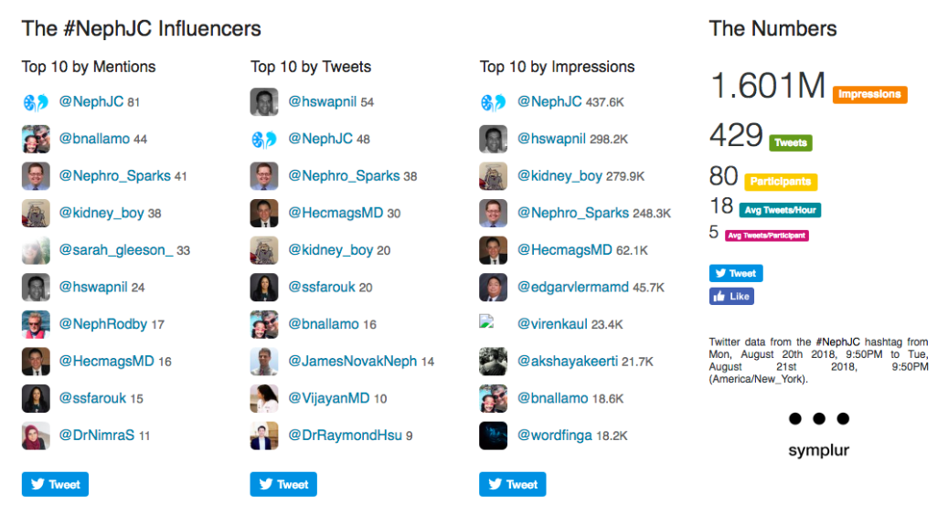
Symplur analytics from the end of a chat conducted on Aug 21, 2018

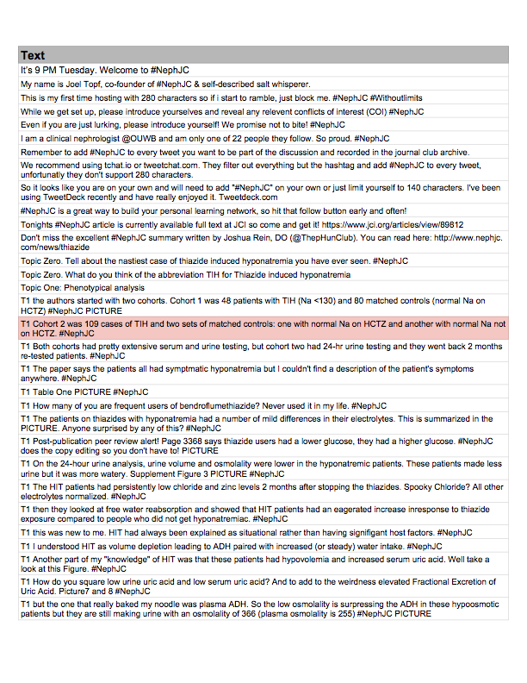
Appendix 1. NephJC Script

Appendix 2. List of Twitter journal clubs

Name | Date | Twitter ID | Hashtag | Active / date of last chat
Twitter Journal Club | 5/2011 | @twitjournalclub | #twitjc | Inactive (12/13)
Public Health Twitter Journal Club | 8/2011 | @PHTwitJC | #PHTwitJC | Inactive (8/13)
British Journal of Obstetrics and Gynaecology Journal Club | 5/2011 | @BlueJCHost | #bluejc | Active
Microbiology Twitter Journal Club | 5/2012 | @microtwjc | #microtwjc | Inactive (1/16)
St Emyn's Journal Club | 10/2012 | @JC_StE | #JC_StE | Inactive (9/14)
Urology Journal Club | 11/2012 | @iurojc | #urojc | Active
Evidence Based Nursing Twitter Journal Club | 1/2013 | @EBNursingBMJ | #ebnjc | Active
Hospice and Palliative Care medicine | 2/2013 | @hpmjc | #hpmjc | Active
Archives of Disease in Childhood's Journal Club | 6/2013 | @ADC_JC | #ADC_JC | Inactive (4/16)
Respiratory and Sleep Medicine Journal Club | 10/2013 | @respandsleepjc | #rsjc | Active
Academic Life in Emergency Medicine Journal Club | 11/2013 | @M_Lin | #ALiEMJC | Inactive (3/15)
General Surgery Journal Club | 2/2014 | @igsjc | #igsjc | Inactive (2/16)
Primary Care Medicine Journal Club | 2/2014 | @pcmjc | #pcmjc | Inactive (3/14)
Allergy Journal Club | 3/2014 | @allergyjc | #allergyjc | Inactive (3/14)
Nephrology Journal Club | 4/2014 | @nephjc | #nephjc | Active
iForumRx Online Journal Club | 5/2014 | @iforumrx | #iforumrx | Active
Radiation Oncology | 8/2014 | @rad_nation | #radonc | Active
Geriatric Medicine Journal Club | 8/2014 | @GeriMedJC | #GeriMedJC | Active
International Psychiatric Journal Club | 12/2014 | @PsychiatryJC | #PsychJC | Inactive (6/15)
Duke Anesthesiology Journal Club | 1/2015 | @Duke_Anesthesia | #AnesJC | Active
Name | Date | Twitter ID | Hashtag | Active / date of last chat
Rheumatology Journal Club | 2/2015 | @RheumJC | #RheumJC | Active
Amyloidosis Journal Club | 10/2015 | @Amyloid_Planet | #amyloidosisJC | Active
GIM Journal Club (General Internal Medicine) | 12/2015 | @GIMJClub | #GenMedJC | Active
General Practice Journal Club | 1/2016 | @GPjournalclub | #GPJC | Active
EAST Journal Club (trauma surgery) | 5/2016 | @EASTjournalclub | #EASTjc | Active
Pathology Journal Club | 7/2016 | @PathJC | #PathJC | Active
Family Medicine Online Journal Club | 9/2016 | @FamilyMedJC | #FamilyMedJC | Active
International Pediatric Nephrology Journal Club | 11/2016 | @IPNA_PedNeph | #IPNAJJC | Active
Twitter Echo Journal Club | 11/2017 | @ASE360 | #ASEchoJC | Active
Intensive Care Medicine Journal Club | 2/2018 | @ICMJC | #ICMJC | Active
Pediatric Hospital Medicine Fellow Journal Club | 9/2018 | @STangGirdwood | #PHMFellowJC | Active

